1. Original Relations

* Product(#prod, pname, price)
* Depot(#dep, addr, volume)
* Stock(#prod, #dep, quantity)

1. ERD

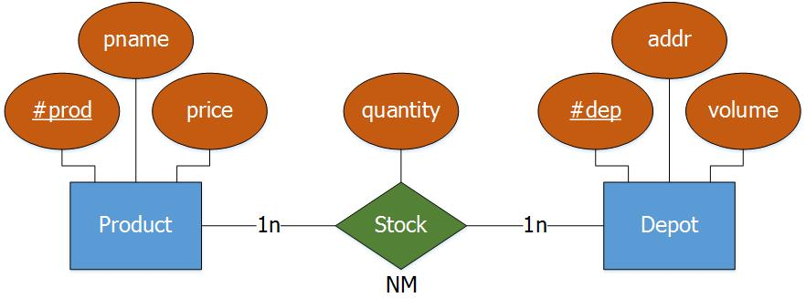

1. Algorithm for converting an ERD to a relation

* Rule 3 (For many-to-many relationship type)
* We create a relation RR with the following attributes: the key of RA, the key of RB and the attributes of the relationship type R.
  + RA(Att(A)) = Product(#prod, pname, price)
  + RB(Att(B)) = Depot(#dep, addr, volume)
  + RR(PK(RA), PK(RB), Att(R)) = Stock(#prod, #dep, quantity)
* Output
  + Product(#prod, pname, price)
    - PK(Product) = #prod
  + Depot(#dep, addr, volume)
    - PK(Depot) = #dep
  + Stock(#prod, #dep, quantity)
    - FK(Stock) = #prod references PK(Product(#prod))
    - FK(Stock) = #dep references PK(Depot(#dep))
    - PK(Stock) = #prod, #dep